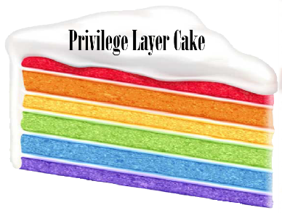
Privilege Layer Cake
Possible Guiding Questions for Small Group Discussions

The following guiding questions have been used in previous iterations of the Privilege Layer Cake (PLC) activity. PLC typically has two separate small group, breakout sessions. The questions are divided up into those two sections. Please note that these are not the only possible breakout questions. Those planning to implement PLC as an activity should feel free to explore other questions that they may feel are equally relevant to supporting discussion and conversation.
Discussion #1: Individual Perspective
- What privileges were you born with?
- What privileges have you earned?
These are the two standard questions for the activity and the only two recommended for any interaction of PLC
- How do those privilege layers interact?
- What do the different privileges represent?
- What aren’t we considering about these layers?
- What factors influence interaction of privilege layers.
Discussion #2: Group/Team/Organization Perspective
- What privileges do we assume patrons have to use our services?
- What privileges do we assume libraries and/or library staff have in serving their communities?
- What privileges does [NAME OF LIBRARY/ORGANIZATION] provide/extend to the [communities/libraries] we serve?
- How are or can those privileges be passed along to the various communities libraries serve?
- How can knowing about the privileges of your colleagues/coworkers impact the work environment?

